- Create and Test a Kubernetes Pod with an EmptyDir Volume.

Step 1: Create Pod YAML with EmptyDir Volume

Create a file called `emptydir-pod.yaml`

vi emptydir-pod.yaml

apiVersion: v1
kind: Pod
metadata:
name: emptydir-pod
spec:
containers:
- name: firstcontainer
image: nginx
volumeMounts:
- mountPath: /data #Directory inside container
name: first-volume #any logical name
volumes:
- name: first-volume
emptyDir: {} #Blank Object

Explanation:

* emptyDir → temporary storage created when the pod starts
* Container share the same /data directory
* Data exists only while the pod is running

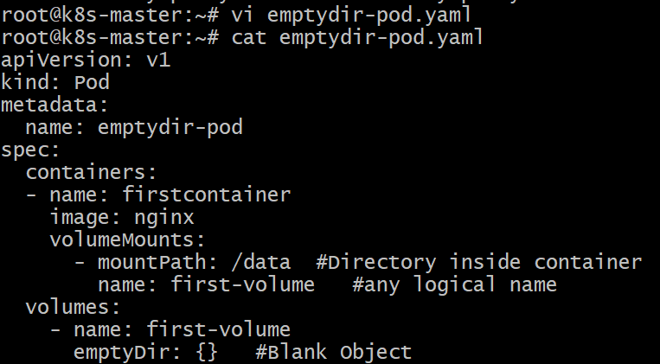

Step 2: Apply the Pod

kubectl apply -f emptydir-pod.yaml

Expected output:

pod/emptydir-pod created

Step 3: Verify the Pod

kubectl get pods

Example output:

NAME READY STATUS
emptydir-pod 1/1 Running

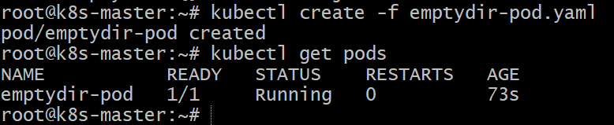

How to test:
1) Login to container and create some random files in /data location.
2) Stop nginx service to terminate your container.
3) Now you can see pod will create a new container and try to login into container
4) Files in directory /data will be visible.
Step 4: connect to the pod and create a files in /data location

kubectl exec -it emptydir-pod -- sh

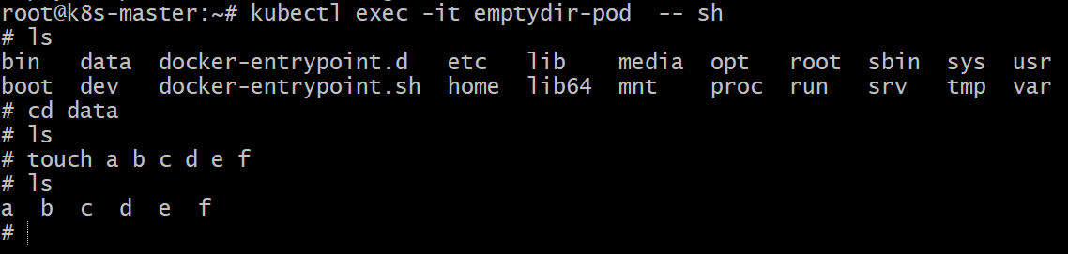

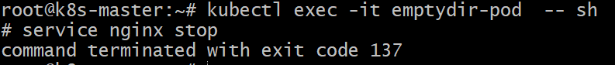

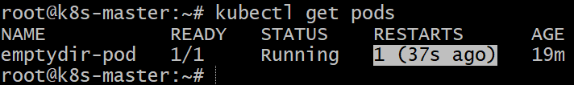

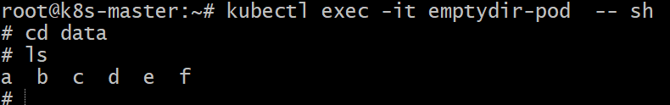

Step 5: Delete the Pod

kubectl delete pod emptydir-pod

When the pod is deleted, the **EmptyDir data is also deleted**.

Conclusion

In this task, we created a pod with an EmptyDir volume , demonstrating how EmptyDir allows containers within a pod to share temporary storage. The data exists only for the lifetime of the pod and is removed once the pod is deleted.

- Configure a HostPath Volume in Kubernetes and Validate Data Persistence

- Deploy an Amazon EBS Volume Using Persistent Volume and Persistent Volume Claim (PVC)

- Set Up an Amazon EFS Volume and Attach it to Multiple Pods

- Implement and Test Liveness and Readiness Probes in a Kubernetes Pod

